**Assignment – 2**

 

* **Connect to the Store Sales Data and do the following: -**

− Remove all the blank rows.

− Update the column header if they are not updated

**Output:**

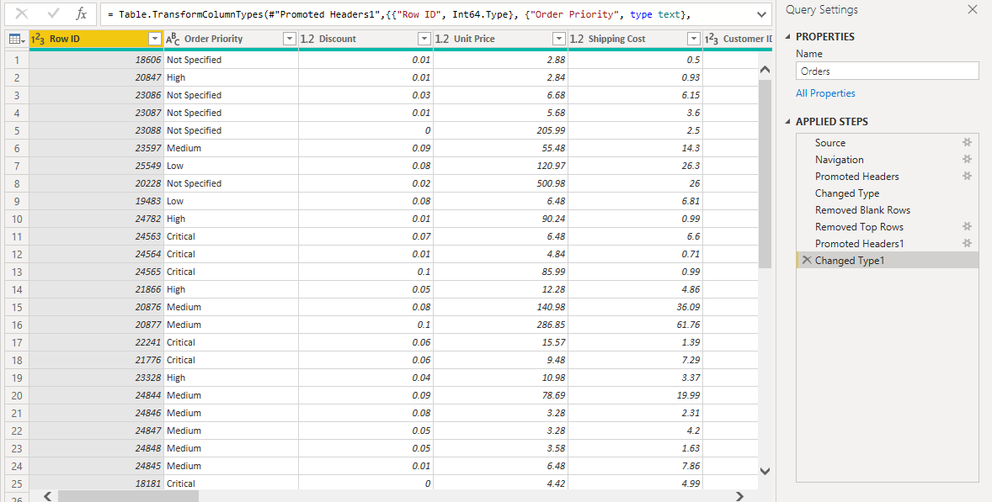

− Create a text table and show the sales in terms of

* Customers
* Product Category
* Regions

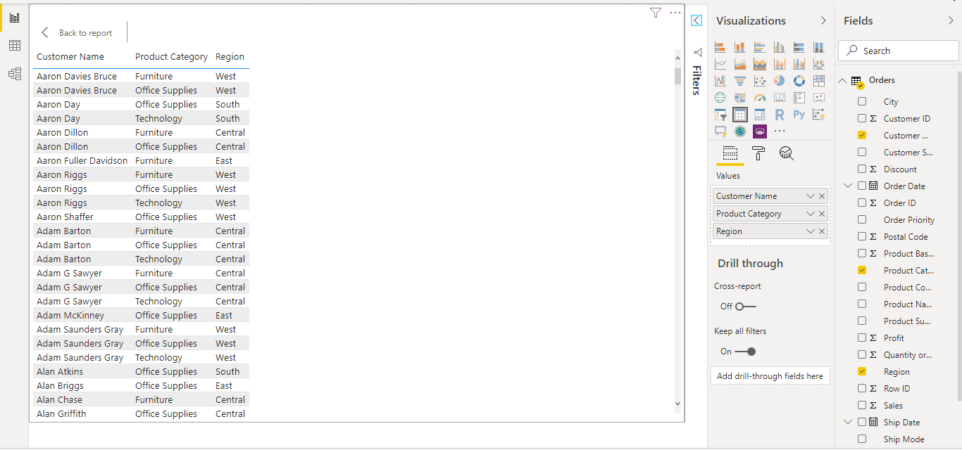

* **Create a line and Clustered Column Chart showing the Sales and Discount as per the State or Province**

− Format the bars and line with different colours

− Which state has the highest sales in terms Technology

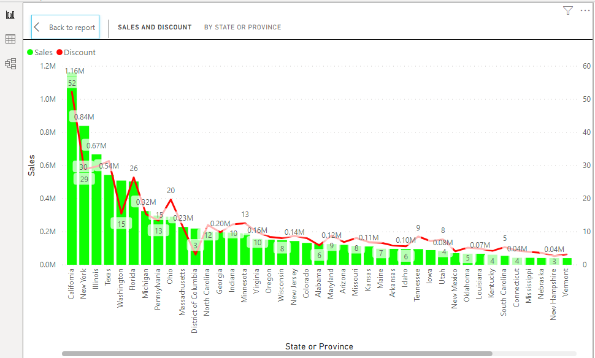

• **Create a** *Donut Chart* **showing sales in terms of Product category**

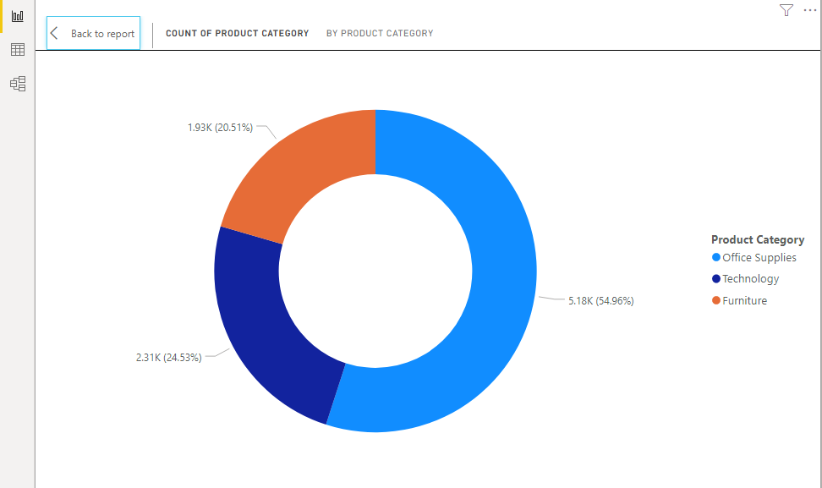

• **Create a** *Slicer* **and show the regions in dropdown. See how all the visuals mentioned above behaving when a particular region is selected.**

Please see the Power BI file.